**Practical 9**

|  |  |
| --- | --- |
| Roll No. A016 | Name: Varun Khadayate |
| Program: B-Tech (CSBS) | Division: SY |
| Batch: 1 | Date of Experiment: 22-09-2020 |
| Date of Submission: 22-09-2020 | Grade: |

**(PART – A)**

***Aim: To convert CFG to PDA***

**Outcome:** After successfully competing of this practical, students will be able to learn:

* What is PDA, CFG?
* Converting context free grammar to PDA

**A.1 Reading**

Read Page 98 to 106

**A.2 Tasks**

1. Develop a PDA (LL) for the following grammar

S -> (S)S | €

1. Develop a PDA (LR) for the following grammar

S -> aSa | bSb | X

**PART B**

(PART B: TO BE COMPLETED BY STUDENTS)

**(Students must submit the soft copy as per following segments within two hours of the practical. The soft copy must be uploaded on the Portal or emailed to the concerned lab in charge faculties at the end of the practical in case the there is no portal access available)**

**B.1 Output:**

1. Write a procedure to generate the PDA from CFG using JFLAP tool.

**PDA (LL) generation**

* 1. Generate a grammar for S -> (S)S | €
  2. After loading the grammar, click on Convert and click Convert CFG to PDA (LL).
  3. We have successfully transformed the context-free grammar to a pushdown automaton.
  4. We can export this PDA and test it on some inputs to see if the converted PDA accepts the same string as our original CFG.

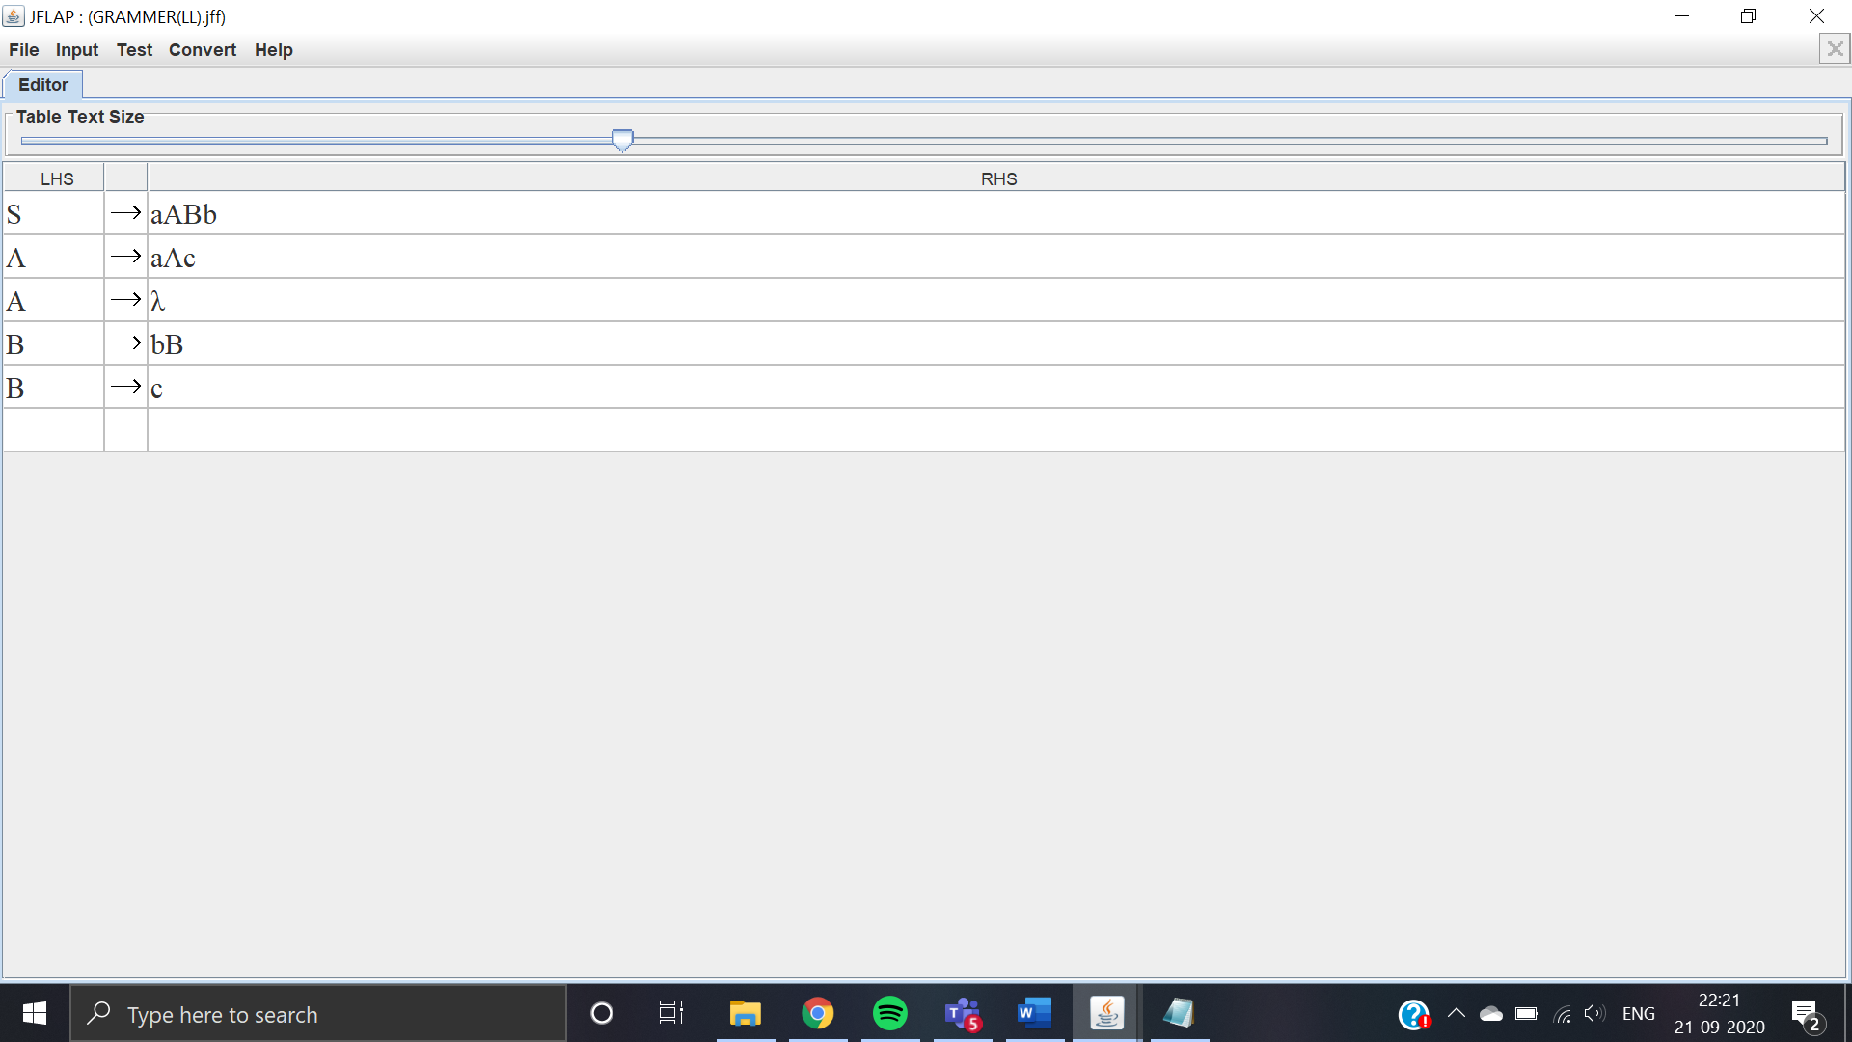

Generated Grammar

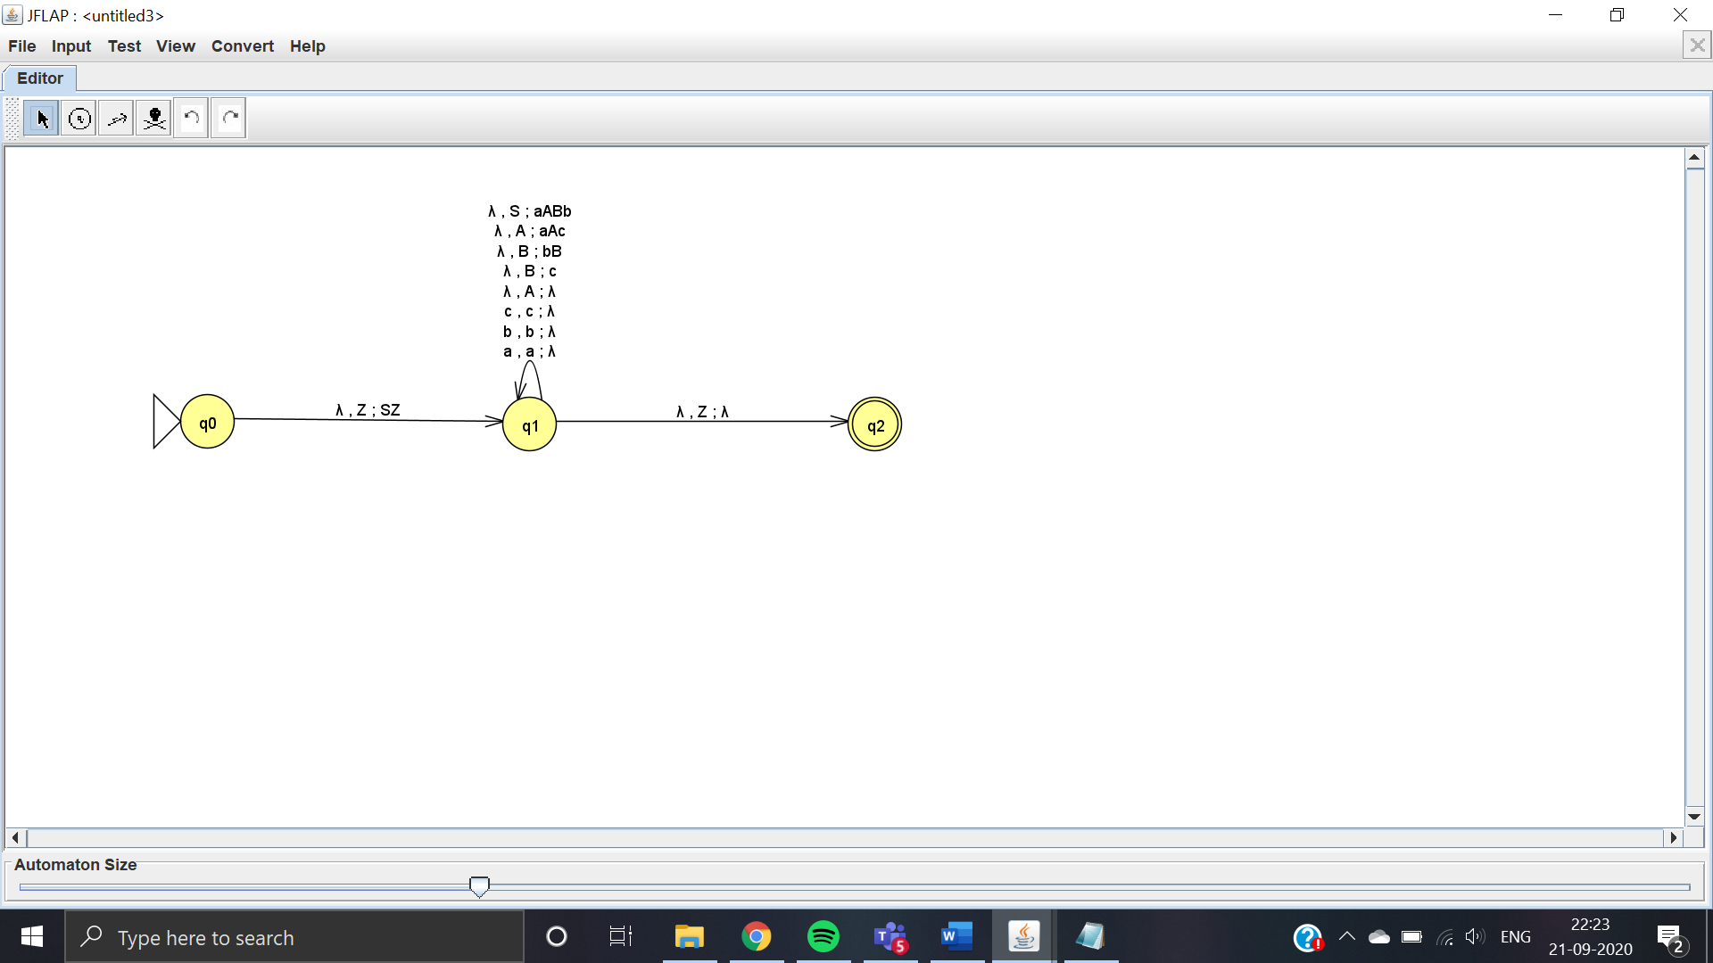

Grammar Converted to PDA(LL)

**PDA (LR) generation**

1. Generate a grammar for S -> (S)S | €
2. After loading the grammar, click on Convert and click Convert CFG to PDA (LR).
3. We have successfully transformed the context-free grammar to a pushdown automaton.
4. We can export this PDA and test it on some inputs to see if the converted PDA accepts the same string as our original CFG.



Generated Grammar

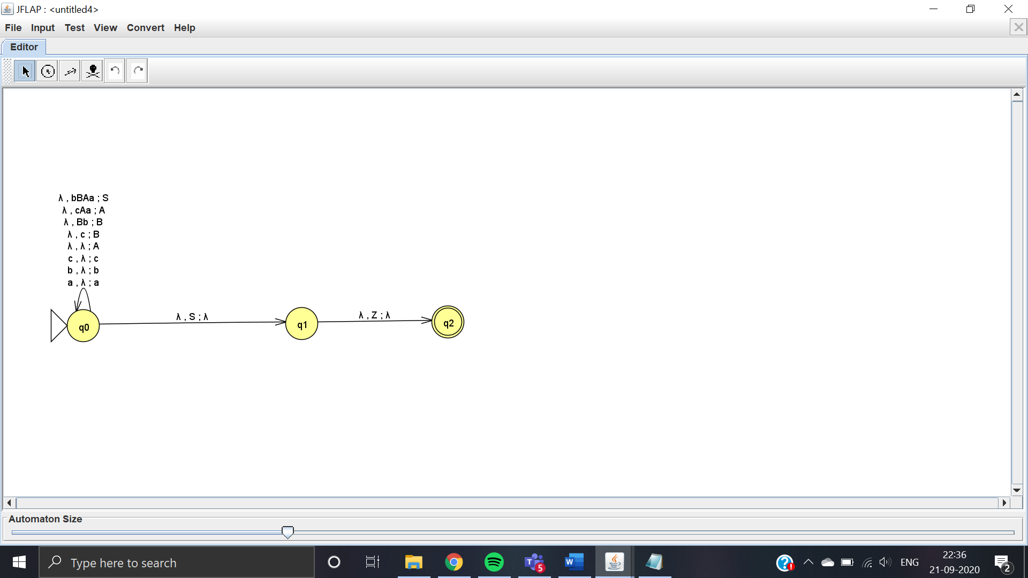

Grammar Converted to PDA(LR)

**B.2 Observations/Learning**

*(Students are supposed to write the logic of constructed DFA and generated regular expression)*

We are able to form a grammar of given expression and convert it to both LL and LR types of PDA.

**B.3 Conclusion:**

*(Students must write the conclusion as per the attainment of individual outcomes and learning/observation)*

The conclusion was derived from the experiment was that both the PDA(LL) and PDA(LR) accepts the strings that contain equal number of a’s , b’s and c’s.

***B.4 Curiosity Question***

***Can you generate a general formula to find total number of states when positions of particular input is fixed from left hand side? Explain***